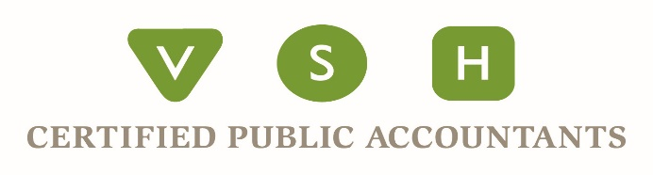
vshcpa.com
BELLINGHAM OFFICE
Phone: 360 734-8715 Fax: 360-738-1176
2200 Rimland Drive - Suite #205 - Bellingham, WA – 98226
SKAGIT OFFICE
Phone: 360 707-4290 Fax: 360-738-1176
1404 E College Way - Suite #100 – Mt Vernon, WA - 98273
BC Phone: 604 531-6638 AB Phone: 587 293-9595

Retirement Plan Distributions Relief Available to Individuals Under the CARES Act
To aid individuals during this time of economic uncertainty, the CARES Act has a few provisions that change some of the rules for retirement plan distribution rules, allowing qualified individuals access to their retirement funds. Below we have summarized what you need to know about retirement plan relief under the CARES Act.

To qualify for the IRA and retirement plan changes mentioned below, the distribution must be coronavirus related. What does that mean exactly?
- The individual, the individual’s spouse, or a dependent was diagnosed with COVID-19 or is experiencing adverse financial consequences as a result of being quarantined, furloughed, laid off, or having work hours reduced due to COVID-19.
- If an individual is unable to work due to lack of childcare, as a direct result of COVID-19, then they also qualify.
- Finally, if an individual’s business is closed or has reduced its operating hours as a direct result of COVID-19, they are also eligible.

Coronavirus Related Distributions and Taxes
Participants of retirement plans are generally not allowed to take distributions from their plans before age 59 ½ without a penalty and without paying taxes. Under the CARES Act, qualified individuals may remove up to $100,000 between January 1, 2020, and December 31, 2020, and have several provisions that reduce, eliminate, or extend the penalties and taxes.
- For qualified coronavirus distributions, the 10% penalty on early distributions from qualified retirement plans, including IRAs and 401(k)s will be waived.
- Qualified rollover distributions are exempted from the 20% Federal tax withholding.
- Taxpayers may repay distributions over three years, so avoid taxation.
- Qualified participants can choose to take the income from their distributions over 3 years.

Defer Required Minimum Distributions (RMD)
For calendar-year 2020, there is a temporary waiver of required minimum distributions from a retirement plan or IRA. This includes traditional IRAs of those over age 70.5 as well as inherited IRAs.
It is important you speak with your CPA to determine if you should take advantage of this provision. For example, if you expect to be in a lower tax bracket due to COVID-19, taking an RMD out of your IRA might be advantageous.

If you have already taken the 2020 RMD, then you would have to include it in gross income and pay taxes on it. However, you have a couple of options in this scenario. For example, you can return a distribution to an IRA for up to 60 days.

Remember, since the tax return filing deadline has been extended to July 15, that also extends the deadline for contributing to an IRA.

Retirement Plan Loan Rules Modified
The CARES Act modifies the rules around loans to qualified individuals between March 27, 2020, and September 23, 2020, by:
- Increasing the maximum loan to $100,000.
- Allowing participants to take the full amount of their vested benefit as a loan.
- Delaying the due date for one year for loan repayments due between March 27, 2020, and December 31, 2020, from qualified individuals. This also extends the five-year repayment period.

