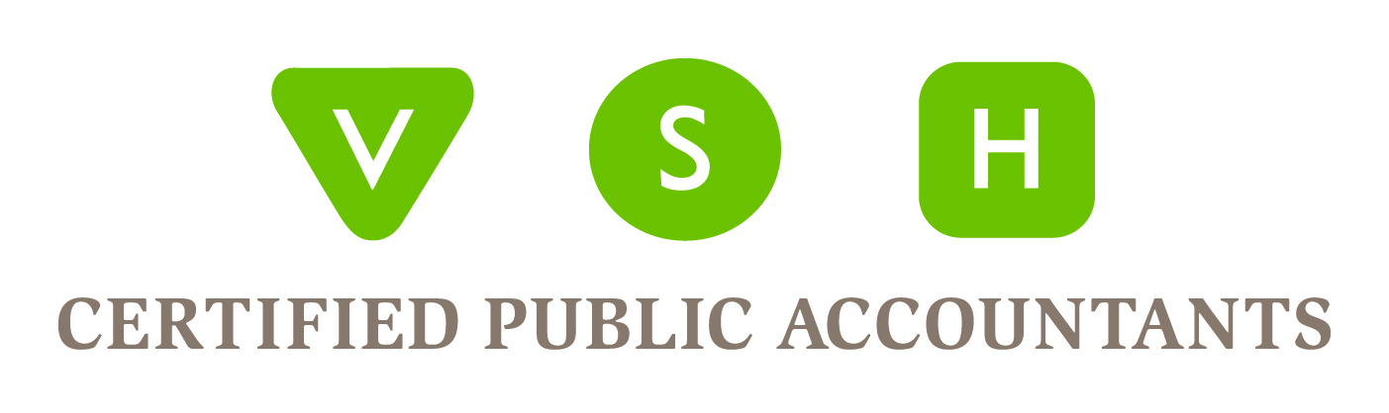
vshcpa.com
BELLINGHAM OFFICE
Phone: 360 734-8715 Fax: 360-738-1176
2200 Rimland Drive - Suite #205 - Bellingham, WA – 98226
SKAGIT OFFICE
Phone: 360 707-4290 Fax: 360-738-1176
1404 E College Way - Suite #100 – Mt Vernon, WA - 98273
BC Phone: 604 531-6638 AB Phone: 587 293-9595

Tips and Considerations for Small Businesses Applying for an SBA Disaster Loan

Small businesses are now eligible for up to $2 million in Economic Injury Disaster Loans from the Small Business Administration (SBA). President Trump has called for an additional $50 billion in funding to the SBA’s lending program from Congress. While the $50 billion is not yet approved, the SBA can issue an Economic Injury Disaster Loan declaration, thanks to the Coronavirus Preparedness and Response Supplemental Appropriations Act.

Knowing what to expect before starting the loan process will help prevent unnecessary errors and rework. Completing the application process quickly and accurately will be key as there will be high demand and processing times will likely increase. We’ve put together the following summary of what business owners can expect when applying for an SBA loan.

Before you get started, you will want to:

Determine eligibility.
Remember, your business must be located in an SBA-declared disaster area to be eligible for the SBA Disaster Loan. To find out if your state is an SBA-declared disaster area visit: https://disasterloan.sba.gov/ela/Declarations/Index

Gather the required documents. You will need:
- Signed IRS Form 4506-T
- Copies of your most recent federal income tax returns for the business
  - If you have not yet prepared 2019, you can provide 2018
- The last three year’s Profit and Loss Statements
- Owner’s Personal Financial Statement 7(a)/504 Loans and Security Bonds
  - Each owner included on SBA Form 5 will need to provide a personal financial statement. This step can be time-consuming if there are above average real estate holdings, investments, or complex liabilities to report.
- Schedule of Liabilities
- Completion of truthful information certification in the form of an e-signature

A disaster assistance loan officer may also request you to fill out additional forms, such as a fee disclosure form and compensation agreement.

Set your expectations.
- Set aside at least 2 hours to complete the application. It is ideal to complete this application in one sitting. Due to high volume, pages can often take 30-45 seconds to load. If you receive an error message, try refreshing pages or navigating backward.
- At times during the process, it may be advantageous to have two web-browsers ready. For example, there have been reports of the e-signature portion not functioning properly on Google Chrome.
- The application will require business owners’ information, including date of birth and social security number. Whoever completes the application must have the authority to access this information as well as sign documents and request tax transcripts.

Begin the application.
To apply for a COVID-19 Economic Injury Disaster Loan, visit: https://covid19relief.sba.gov/#/

Complete the application.
To begin, you will be asked to input basic business information and basic business owners’ information.

Submit Additional Information
Upload your completed application and supporting documents by dragging and dropping them into the ‘upload your documents’ section of the online application. There is also an option to mail the required documents. It is essential to sign and date all forms as incomplete applications will not be accepted.

Review and Submit.
Stand by, ready for questions. From the time the application is submitted, approval can take several weeks. During this time, be available for additional follow-up questions in the event more documentation is required. The entire process from application to funding generally takes 30 to 90 days.

We have heard reports that after submitting the application process online, applicants have received an email acknowledgment that their application was received.

There are three ways in which you can monitor your application status: by phone, online, or email.

